DAT 510 uCertify Lab Activity Worksheet

Module Labs
7.6.7 Training k-Means Clustering

Lab Screenshots
7.6.7 Training k-Means Clustering

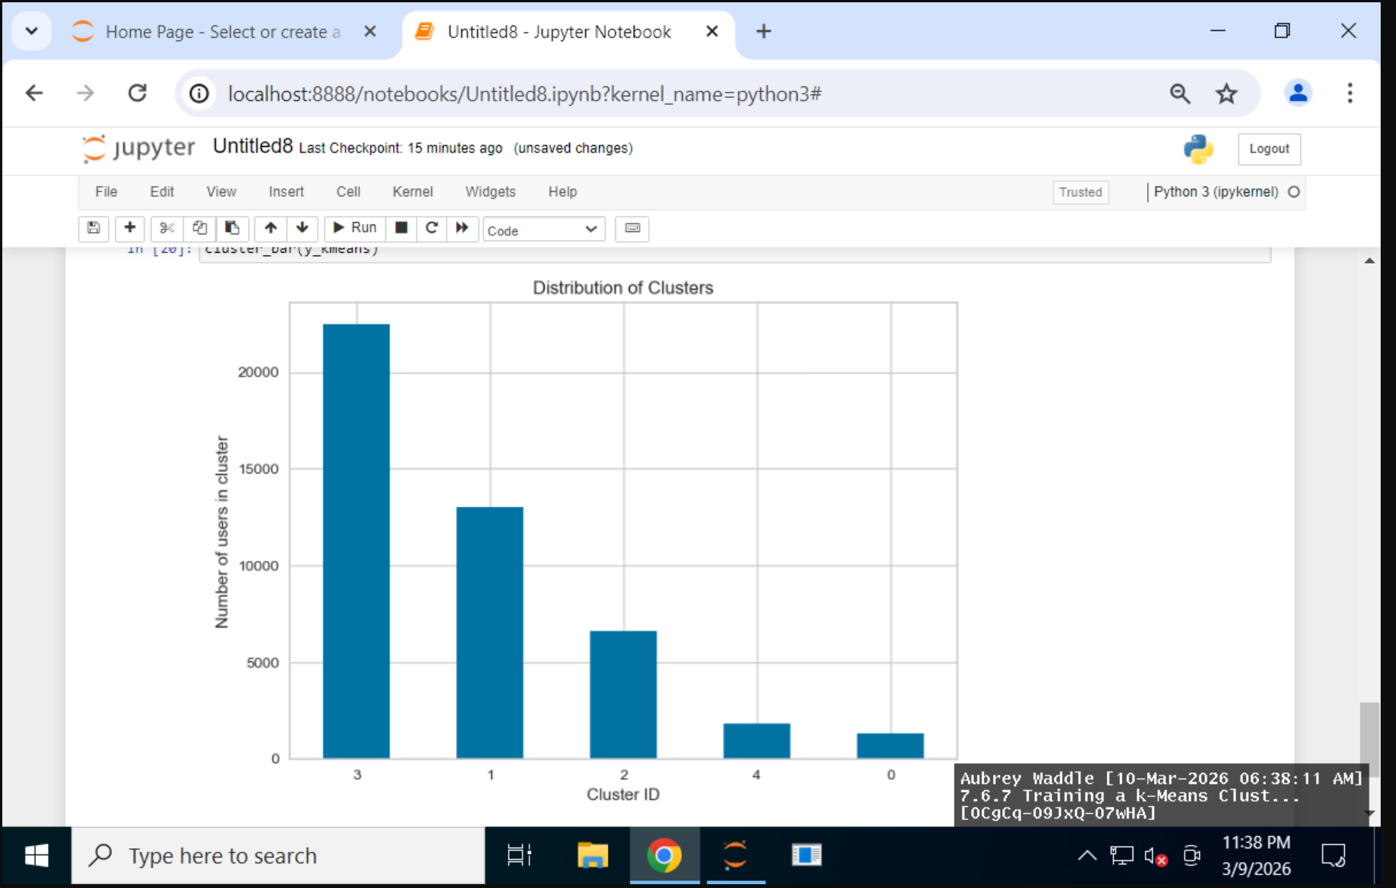

Lab Reflection
7.6.7 Training k-Means Clustering

I used Python and some data analysis modules in the uCertify lab this week to look at and group a dataset of user transaction and demographic information. I used Pandas to load the data and look at it with functions like head(), shape(), and info() to get a feel for how the dataset was put together. After I got rid of demographic data like employment and education, I used description() to look at the summary statistics. After that, I used scikit-learn's StandardScaler to make the data all the same size. Putting all the variables on the same scale made it easier to group them.
I used a K-means clustering method to put people into five groups based on how similar they were after I got the data ready. I used the model to guess which group each person would belong to and put those guesses into a new DataFrame. Finally, I used Matplotlib to make a bar chart that showed how the users were spread out across the clusters. People who work in business intelligence, marketing, or customer analytics can use these methods because clustering helps them see how customers act in patterns. Charts like the cluster distribution chart will be very useful for people in charge who need to quickly see how different groups of data look.

